# Aws S3 Task-1

1. Create an S3 bucket and upload some objects to S3.

* Create s3 bucket. First click on create s3 bucket > select bucket type general purpose > provide a unique name in bucket name > In object ownership select ACLs disabled.

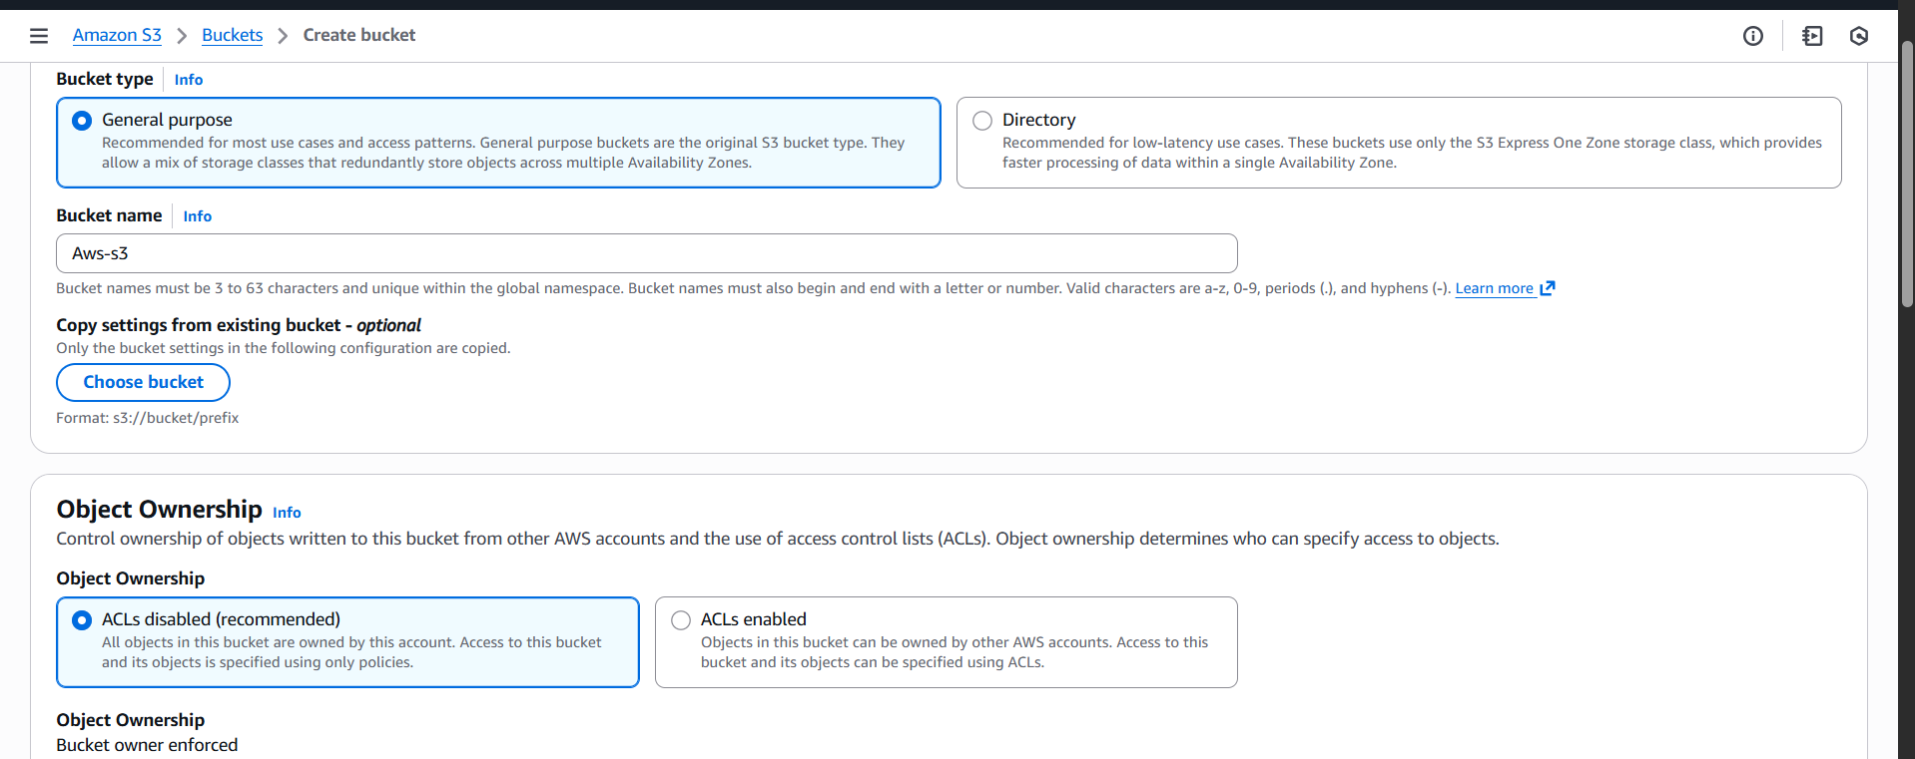

* In bucket key select enable and click on create bucket.

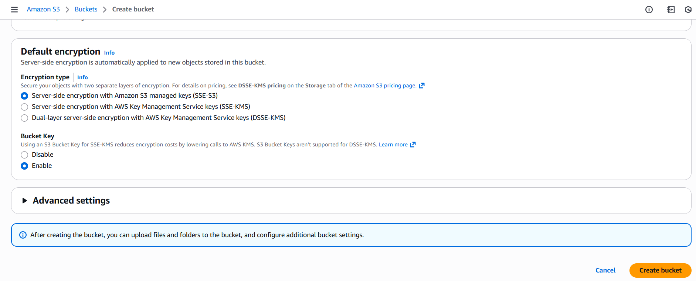

* Validation: As we can see in below screenshot that s3 bucket named techietask has been created.

* In techietask s3 bucket. Select Add files > select file App server & webserver task > click on upload

* As we can it is uploaded now

* Now before copying object url, first give public permissions for the file and copy the link.

* Validation: after running url in browser, as we can see below screenshot file has been downloaded.

1. Deploy a static website in the S3 bucket.

* First,I have uploaded two files index.html and error.html > upload

* scroll down to static website hosting > click on edit.

* Enable static website hosting > select Host a static website in hosting types > enter respective file names in index document and error document > click on save changes.

* As we can see below that static website hosting has been created sucessfully

* Two both files index.html and error.html go to object actions and click on make public using ACL and save changes.

* Copy index.html object url and run it in browser. As we ca see below are the outputs

* Copy error.html object url and run it in browser. As we ca see below are the outputs

1. Enable cross-region replication on S3 buckets.

* First step, As I already haves3 bucket in Europe I have created another one in north Virginia
* Create s3 bucket. First click on create s3 bucket > select bucket type general purpose > provide an unique name in bucket name > In object ownership select ACLs enabled.

* Untick the block all public access > select enable bucket versioning > click on create bucket

* As we can s3 bucket techienv has been created

* Select bucket > management > scroll down to replication rules > click on create replication rule

* Once created role, now it comes to this page, keep everything default here and click on next.

* Select replicate in operation

* Select create new IAM role and click on next.

* Once job created, run the job in status I will reflect completed 100%

* Now, go to destination s3 bucket and check whether files from source is reflected are not.
* In the below screenshot. We can see all the files from source.

4.Configure a bucket policy so only the Admin user can see the objects of the S3 bucket.

* Create an IAM user and give name to it.

* In set permissions > select Attach policies directly in permissions options > in permissions policies select s3 full access and admin access.

* Here we can that policies are created successfully

* Enter json format policy script and save it. And gave full access permissions for Adminuser only.

* I have created two users one is Adminuser with full s3 access and other tasks3 user for validation purpose with s3 access

* First, sign out from root user and sign in with Adminuser. As we can in below output in s3 bucket we can see all the files in it. Because Adminuser has s3 full access and in s3 bucket > techietask > permissions > bucket policy we gave full permissions for Adminuser.

* Validation: As we can in below output in s3 bucket we are not able to see any files in it. Because even though tasks3 has s3 full access in user level. But it does not have permissions in bucket policy. That is why we can’t see any files in it.

5.Set up lifecycle policies to automatically transition or delete objects based on specific criteria.

* Go to s3 bucket > select techietask > select management > click on lifecycle > click on create > gave name task3 > selected first option in lifecycle rule actions > in Transition current versions of objects between storage classes choose all the requirements and days. Click on create.

* As we can see below lifecycle has been created and enabled. Now it will run after 30 days.

6.Push some objects to S3 using the AWS CLI.

* First connect to aws using aws configure with access key and secret key.
* Once connected create an file and push it to aws s3 bucket
* Using command: aws s3 cp filename s3://s3 bucket name/ I have pushed the file to aws s3.

* As we can see below that file project has been reflected in s3 bucket.

7.Write a Bash script to create an S3 bucket.

* Create a file tasks301 and enter bash script to create s3 bucket.
* Give the permissions to execute the script. And and execute it.
* S3 bucket has been created successfully. We can see by ls command.
* We can see the script below.

* As we can see project has been created successfully.

8.Upload a 1 GB file to S3 using the CLI.

* Using this command: “dd if=/dev/zero of=1.5gbfile.bin bs=1M count=1536”. I have created a 1.5 gb file.
* Now, using this command: “aws s3 cp 1.5gbfile.bin s3://tasks301/”. push the file to s3 bucket.

* Validation: As we can see in below screenshot, it is successfully reflected in aws s3 bucket.

